

# The Future of Work

**Public Policy Forum, Toronto**

Mark Carney

Governor

12 April 2018

# First lost decade of real wages since the mid-19th Century

**10 year moving average, per cent**

**4**

**Forecast**

**3**

**2**

**1**

**0**

**-1**

**1850 1865 1880 1895 1910 1925 1940 1955 1970 1985 2000 2015**

2

Source: A Millennium of Data, Bank of England.

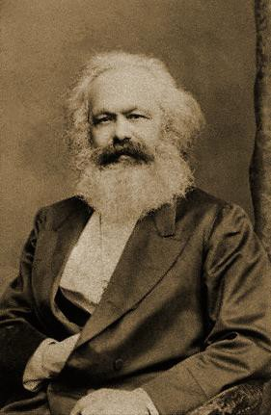 

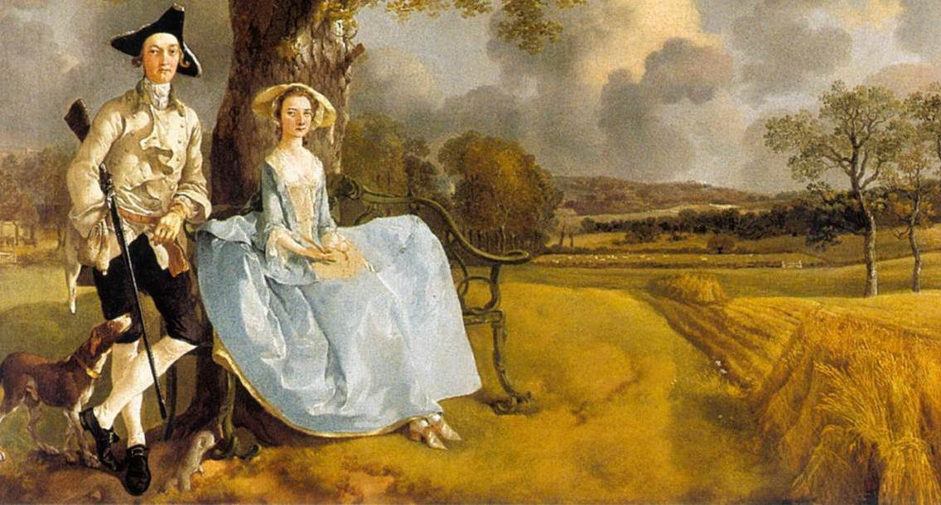

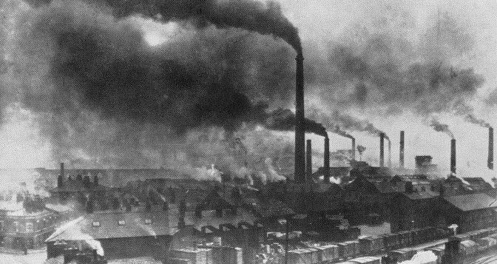

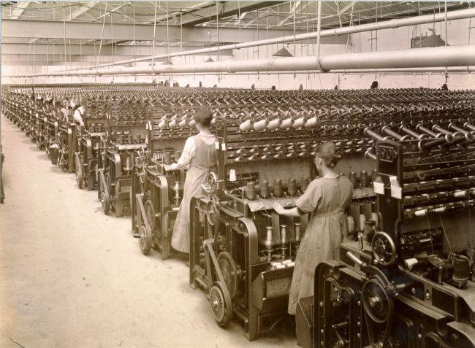



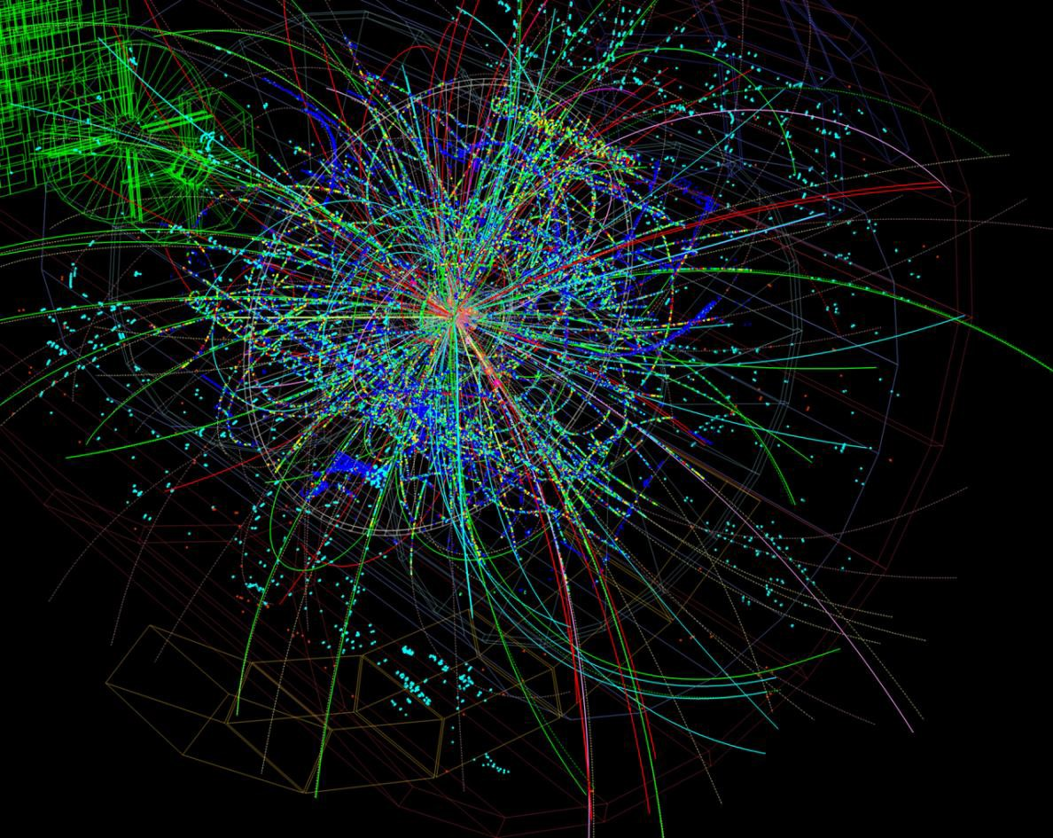

**Employment population ratio (per cent)**

**60**

**1st IR 2nd IR 3rd IR**

**Unemployment rate**

**(per cent) 24**

**50 20**

**Employment population ratio**

**40 16**

**30 12**

**20 Unemployment rate 8**

**10 4**

**0**

**1760 1780 1800 1820 1840 1860**

**1880 1900 1920 1940 1960**

**0**

**1980 2000** 9

**Output per worker (Index: 1900 = 100)**

**70**

**Real wage (Index: 1900 = 100)**

**70**

**60 Engels' Pause -**

**Growth in output per worker exceeds real wage growth**

**50**

**Output per worker**

**60**

**40 50**

**Real wage**

**30**

**40**

**20**

**10 30**

**1770 1780 1790 1800 1810 1820 1830 1840 1850 1860 1870**

10

Source: A Millennium of Data, Bank of England. Note: series are ten year moving averages







# UK US

**Annual nominal wage growth less short-term inflation expectations (per cent)**

**3**



**1993-2012**

**2013-2017**

**Annual nominal wage growth less short-term inflation expectations (per cent)**

**3**



**1993-2012**

**2013-2017**

**2**

**2**

**1**

**0 1**

**-1 0**

**-2**

**-1**

**-3**

**-4**

**4 5 6 7 8 9 10 11 12**

**Unemployment rate (per cent)**

**-2**

**3 4 5 6 7 8 9 10**

**Unemployment rate (per cent)**

15

Source: ‘Brexit and interest rates’, speech by Ben Broadbent, 15 November 2017

**Per cent**

# share down globally

**Percentage change relative to 1990**

**90/10 ratio Gini coefficient**

**60 25**

**Labour share**

**Relative price of investment**

**58 20**

**56 15**

**54 10**

**52 5**

**5.00**

**4.50**

**4.00**

**0.50**

**0.45**

1990

**90/10 ratio**

**Gini coefficient**

**0.40**

**50 0**

**48 -5**

**46 -10**

**3.50**

**3.00**

**0.35**

**0.30**

**44 -15**

**42 -20**

**2.50**

**0.25**

**40**

**1970 1975 1980 1985 1990 1995 2000 2005 2010 2015**

**-25**

**2.00**

**1960 1970 1980 1990 2000 2010**

**0.20**

Source: IMF April 2017 WEO. Notes: the chart shows the labour share and 16

relative price of investment across advanced economies.

**100 x Change in Employment Share 0.20**

Expanding

**0.15**

**Growth of low-skilled jobs**

**0.10**

**0.05**

**0.00**

**2007-2012**

**1999-2007**

**Growth of high-skilled jobs**

**0 20 40 60 80 100**

**-0.05**

**1989-1999**

Shrinking

**-0.10**

**1979-1989**

**Skill percentile**

**(ranked by occupation’s 1979 mean log wage)**

17

Source: Autor, D (2015) ‘Why Are There Still So Many Jobs? The History and Future of Workplace Automation’, *Journal of Economic Perspectives*, Vol. 29, No. 3, pp.3-30.

**Real wage level of full time U.S. male workers relative to 1963**

**2.0**

**1.8**

**Greater than Bachelor’s Degree**

**High School Dropout**

**Bachelor’s Degree**

**Some College**

**High School Graduate**

**1.6**

**1.4**

**1.2**

**1.0**

**0.8**

**1963 1968 1973 1978 1983 1988 1993 1998 2003 2008**

18

Source: Autor (2014) ‘Education, and the Rise of Earnings Inequality Among the "Other 99 Percent“, *Science*, 23 May 2014, pp 843–851.

**Jobs with tasks at risk by 2030**

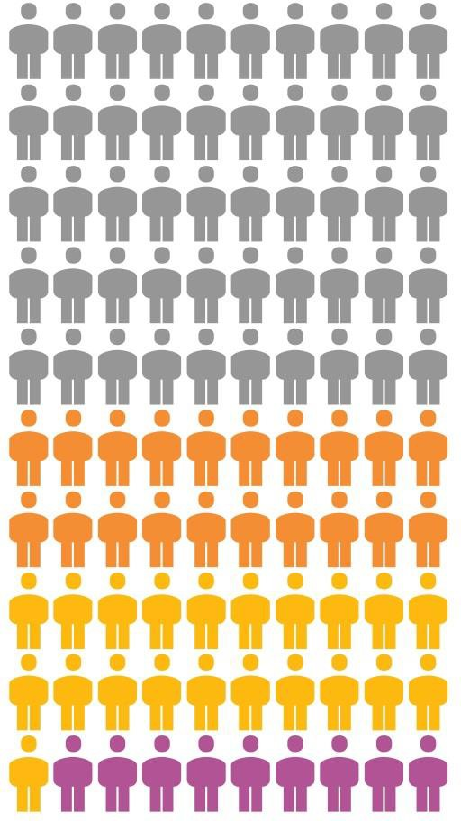

**50%**

**United Kingdom**

***Frey & Osborne (201 McKinsey (2016)***

**30%**

***3)***

**Canada**

**All countries in sample**

***PwC (2016)***

***Haldane (2016)***

**Norway Finland Sweden New Zealand**

**United States**

**Korea Denmark Netherlands**

**United Kingdom**

**Estonia Singapore Canada Belgium**

**All countries in sample**

**Japan Italy**

**Czech Republic**

**Ireland France Austria Germany Poland Spain**

**Slovak Republic**

**0**

**10**

**20**

**30**

**40**

**Percentage of jobs at high risk of automation**

Source: Nedelkoska, L and Quintini, G (2018), “Automation, skills use and 19

**9% *Arntz et al. (2016)***

training”, OECD Social, Employment and Migration Working Paper.

**Technology adoption lag (years)**

**140**

**120**

**100**

**80**

Steam- and motorships

Railways - passengers



Railways - freight

**60**

Telegrams

**40**

Telephones

Cars Trucks

Electricity

Aviation - freight Aviation - passengers

**20** Blast oxygen

MRI units

**0**

Cellphones PCs

Internet users

**1750 1800 1850 1900 1950 2000**

**Invention year of technology**

Notes: Technology adoption lag is a mean estimated lag in cross-country technology diffusion. 20

Source: Comin, D and Hobijn, B (2010), ‘An exploration of technology diffusion’, *American Economic Review*, Vol. 100, No. 5, pp2031-59.

# This time it’s faster?

**1st IR 2nd IR 3rd IR 4th IR? Annual pp change**

**(54 years)**

**(66 years) (34 years)**

**(12 years)**

**2.0**

**1.5**



**Services**

**Agriculture & Mining**

**Manufacturing**

**Expanding**

**1.0**

**0.5**

**0.0**

**-0.5**

**-1.0**

**1817-1871 1871-1937 1973-2007**

**2018-2030**

**-1.5**

**-2.0**

**Shrinking**

|  |  |  |
| --- | --- | --- |
| **Institution** | **Effect** | **Examples** |

|  |  |  |
| --- | --- | --- |
| **Enabling institutions** | Transformed the skill base of workers | Primary, secondary, tertiary and technical education |

|  |  |  |
| --- | --- | --- |
| **New insurance institutions** | Supported those displaced | Unemployment insurance, universal healthcare, state pensions, child benefit |

|  |  |  |
| --- | --- | --- |
| **Labour market institutions** | Influenced provisions and shared the surplus | Friendly Societies, Trade Unions, Co- operatives, minimum wages |

|  |  |  |
| --- | --- | --- |
| **Employers** | Created environments to help employees  thrive | “Model Villages” (providing housing, schooling and recreation), higher pay (Ford’s $5 initiative), occupational pensions |

First:

* Assess and address the skills gap

Then:

* Reduce frictions to applying new technologies
* Deepen Productivity and Creation effects
* Adapt all elements of market ecosystem
* Identify skills mismatches and adopt anticipatory talent management strategies
* More effective workforce training, as skill set of existing employees is rate limiting factor of technology adoption
* Corporate re-training programmes for workers to be retained by company and returned to workforce
* Providers of general purpose technologies explore opportunities to maximise job-creating, augmented intelligence
* Balance labour mobility with appropriate protections of workers in new, non-standard jobs
* Taylor Review of modern working practices suggests people working for platform-based companies be classed as dependent contractors
* Embrace technology-enabled solutions to improve matching and bridge skills gaps
* Enhance benefits and data portability (including reputational histories of dependent contractors)
* Equalise incentives for human capital and physical investment
* Successive IRs developed primary, secondary and tertiary education
* Could 4IR lead to quaternary education?
  + Institutionalise re-training in mid-career
  + Integrated with social welfare system
* Universal support schemes for retraining
  + The UK’s Flexible Learning Fund
  + Singapore’s SkillsFuture programme
* New payment solutions for distributed commerce and real- time P2P transactions
* More effective, platform-based finance for SMEs
* Data-based financing for intangibles
* More efficient cross border transactions and trade finance through better payments plumbing and robust digital IDs
* Expand impact investing to build social capital consistent with new labour market



# The Future of Work

**Public Policy Forum, Toronto**

Mark Carney

Governor

12 April 2018